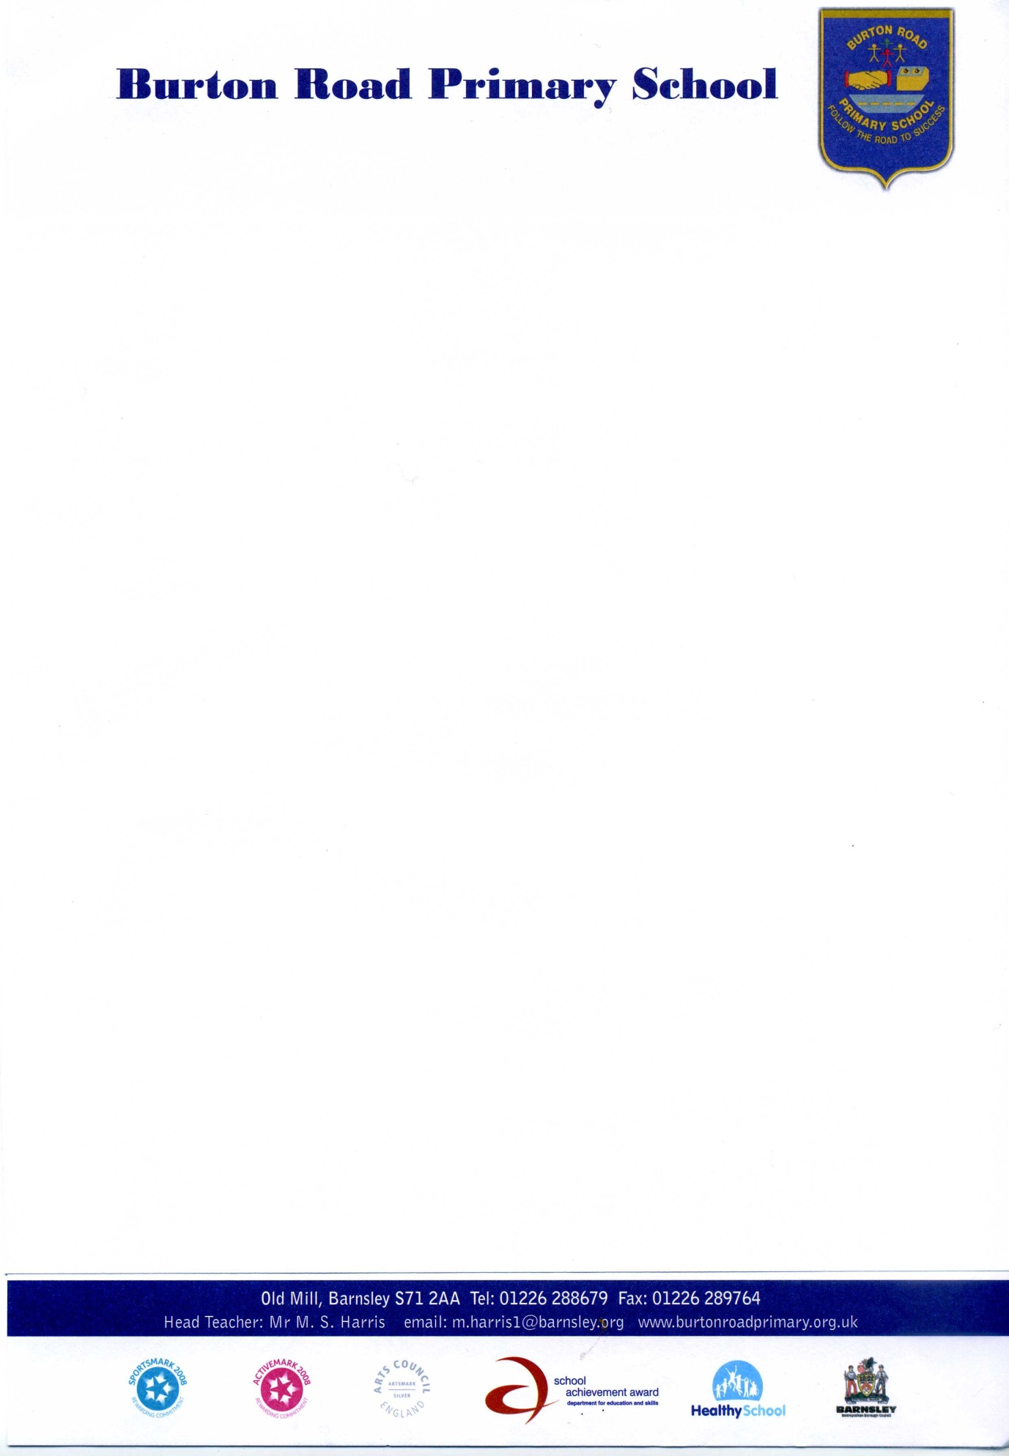
Monday 6th April 2020

Dear Parents,
I hope you and your family are keeping safe and well in these challenging times.
Please find attached below a Well-Being Pack for Easter which may be useful to complete
with your child over the Easter break.
Kind Regards,

Mrs McNicholas


Well-Being Pack for Easter
Life has changed so much for our children and the structure and routine which school
offered was suddenly taken away with everyone now being asked to stay home.
At the moment, there is a lot of worry around because of Covid 19. Having some worry can
be really good because it keeps us safe, but when we have lots of worry, it can make us feel
bad and make it hard for us to manage our feelings. This is normal and you are not alone.
If you are feeling worried or scared, you may find it helpful to try some of the activities in
this booklet.

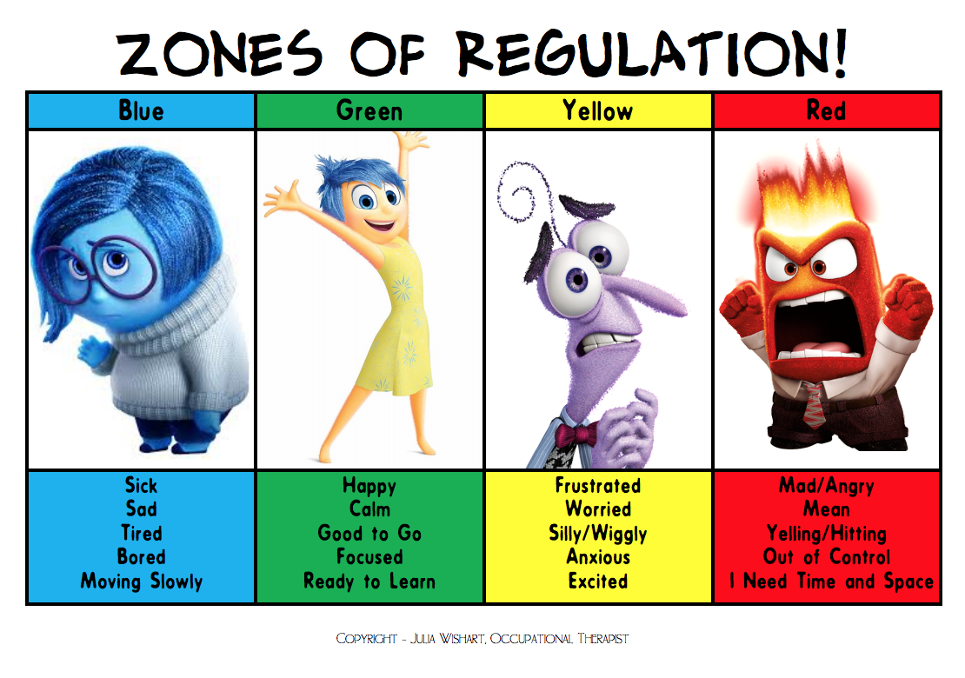
When we are happy and relaxed, our body works fine. But when our brain thinks we are in danger, it sends messages all over our body to get ready to run away from the danger , fight and be ready to meet the danger or freeze, which means we get stuck to the spot. This is a good thing when we want to hide!
Watch the clip ‘Flight, Fright, Freeze’, to find out more.

https://www.youtube.com/watch?v=FfSbWc3O_5M

Colour or tick all the feelings you have had over the last week. Which zones have you been in?
.
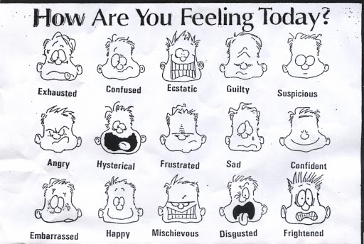

Remember: Your feelings are perfectly normal, but understanding how we are feeling can make things seem less scary.

Have a look at the Blob Tree. Which one do you think you are and why?
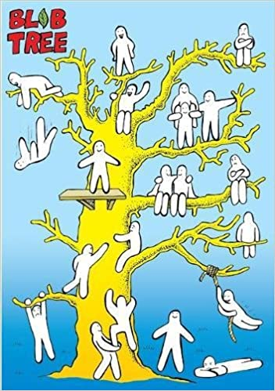

UNCERTAINTY
For many people, the uncertainty about coronavirus is the hardest thing to handle. We don’t know what is going to happen next, or how bad things might get. This makes it easy to think of the worst things that might happen which can leave us feeling really frightened. While these possibilities can be scary to think about, they might not happen and there are things we can do to help relieve at least some of the worry.
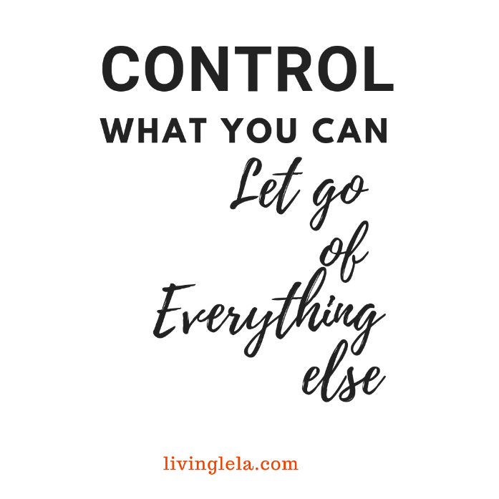
There are so many things we can’t control, which can be tough to accept. You or your family getting ill can be scary to think about, but the best thing to do is concentrate on the things you CAN control.

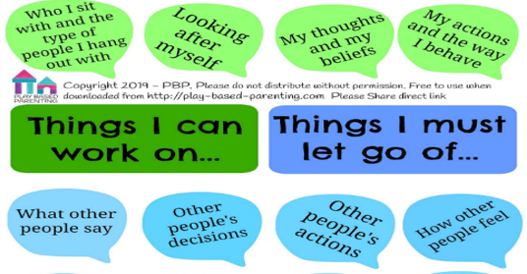
Write down the things you can control and the things you need to let go of.

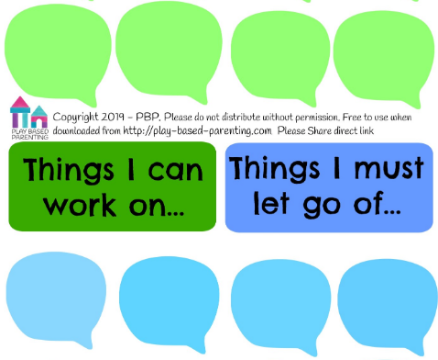
FEELING LONELY
You might feel lonely being inside by yourself. Write down people who care about you and are in your circle.

When we feel uncomfortable, we usually try to find things that make us feel better. You may have tried some of these in class already.

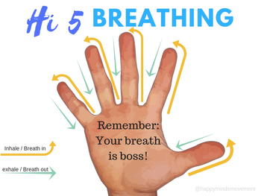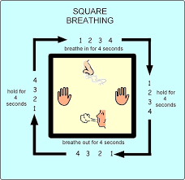

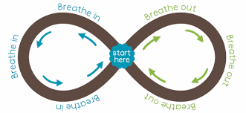
WHALE BREATH 
Take a deep breath in, hold it while you count to 5 with your fingers then tilt head up to blow it out of your blowhole. You can also put your hands up on top of your head to create the blow hole to “blow” out.

RAINBOW BREATHING 
Arms start at the side of your body; arms go up as you breathe in and go down as you breathe out (arms make a rainbow).
OTHER ACTIVITIES TO TRY
- How many things can you see which are square, circles or rectangles etc..?

- How many things can you see which are blue, green or brown..?

- Think of a word to match every letter of the alphabet. Here are some example categories, but you might have others you can think of:

Types of animals
Things you like to eat
Places
Names

Imagine a happy place

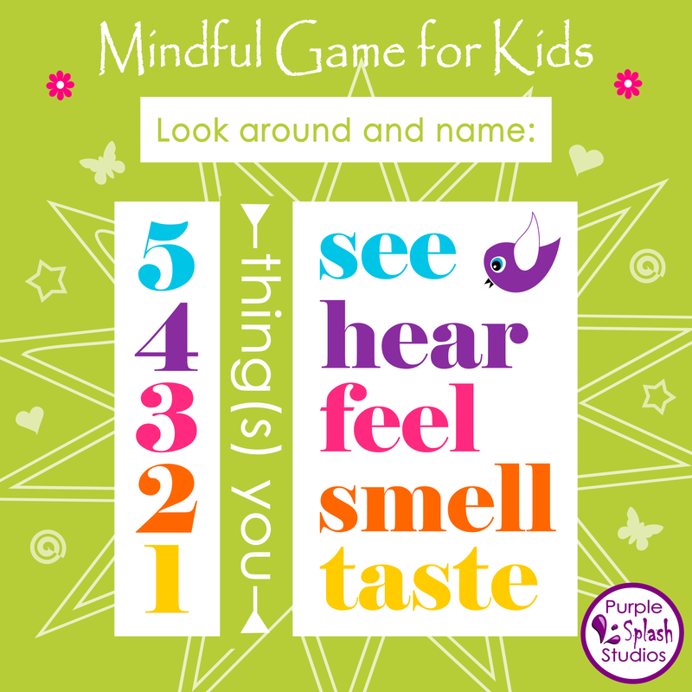

WORRY MOLES

Worries pop into our heads all the time. Everybody worries about things nearly every day.
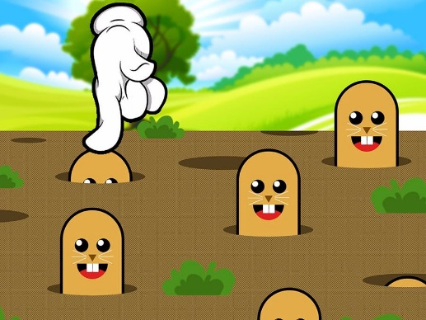
Write down any worries you have had this week. Out of 10, how much do you believe them to be true?

Not at all A little bit Quite a bit A lot
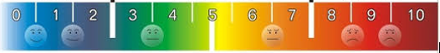

Be Kind to Yourself

Write down some ideas about how you can be kind to yourself. Some ideas have been given to start you off. How can you make these happen, or who would you need to help?

Relax

Be Brave

Laugh

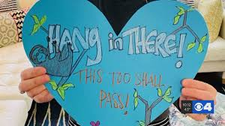
Do something new

Breathing

Gratitude Jar
Every day write down something you are grateful for.
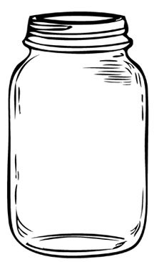

Write or draw
What I love about being at home

What I miss about school

What are you looking forward to doing again?

OPTICAL ILLUSIONS
When we concentrate on what we are doing and what is around us, it can help us feel less worried about what might happen. Try some of the activities on the next few pages.

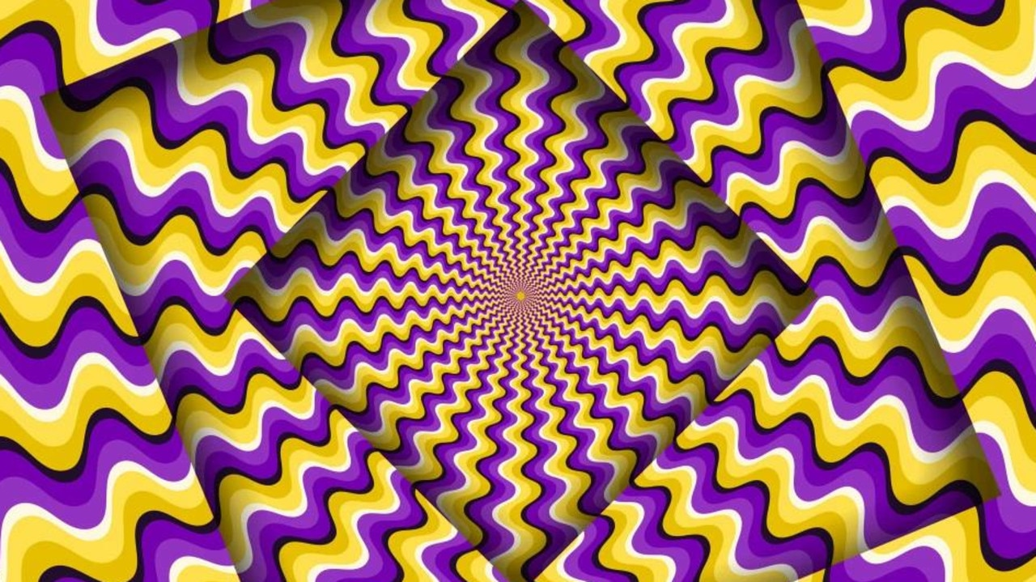
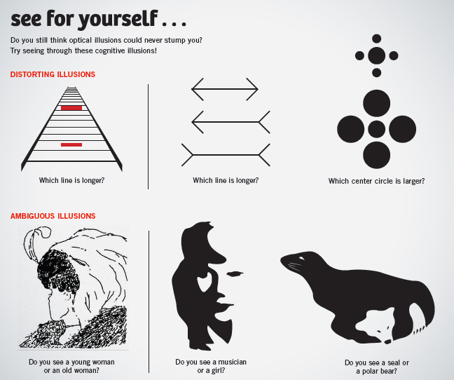


Have a go at drawing your own optical illusion
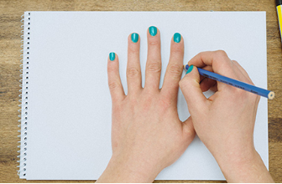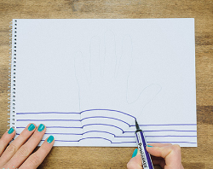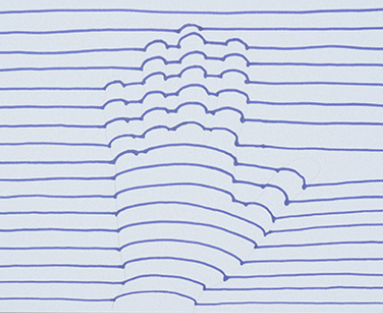

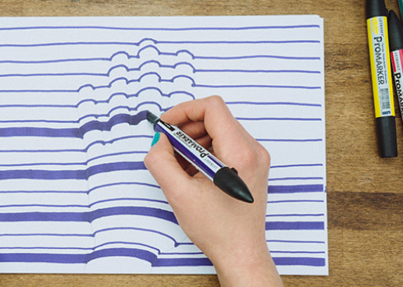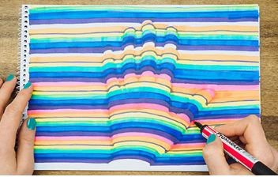
Use 3 different colours and always repeat the same order of colours.
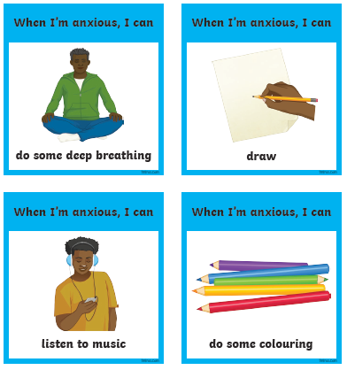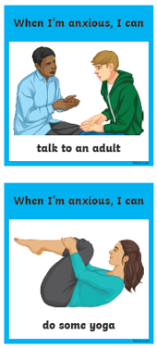
Choose a pencil (or coin) and look at it.
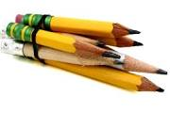
Notice the colour.
Does it have any marks?
How long is it?
What shape is it?
How sharp is it?.
Is it smooth?

Now put it in the middle of the table with other peoples’ pencils.
Mix them up.

Which one belongs to you?

Try this with different objects.


