What we are learning
Years 3 & 4 – Classes 6, 7, 8
Spring 1 - 2025
Geography – Continents and Countries
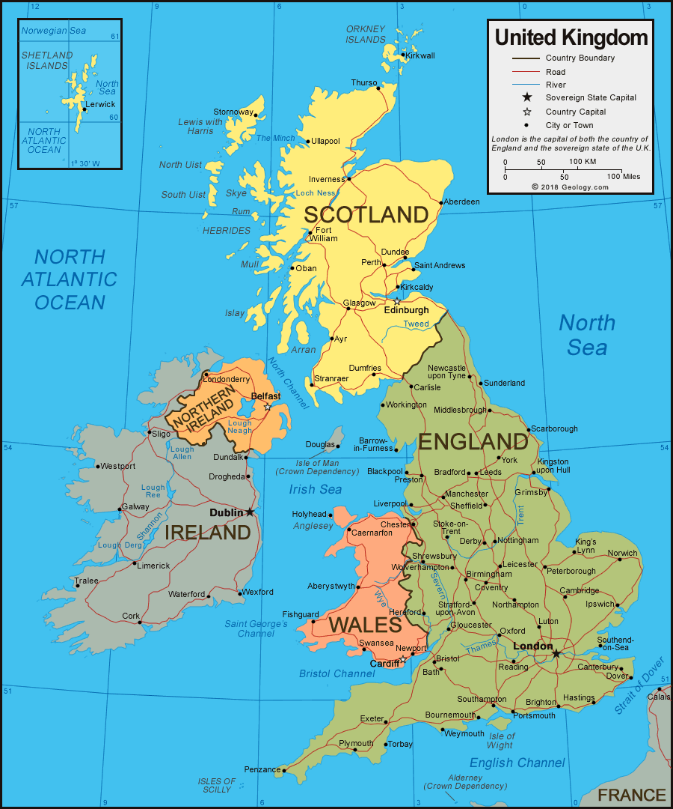
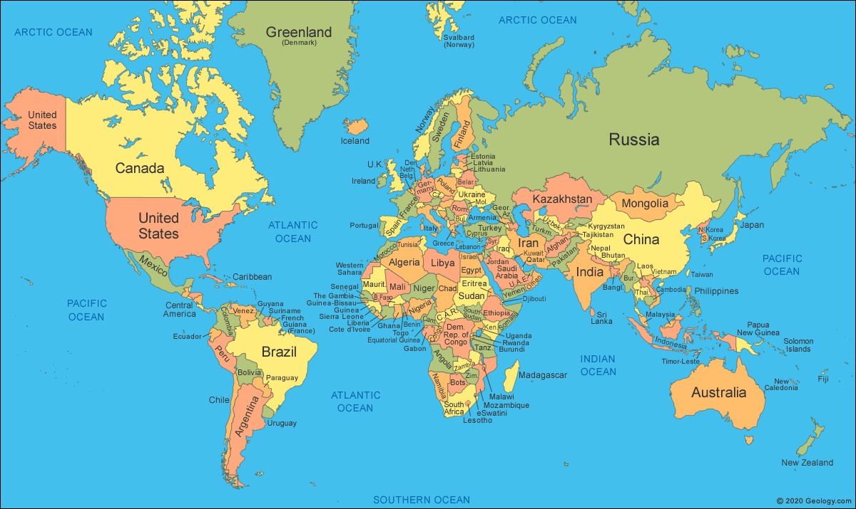

Learning Objectives: | Vocabulary
To know the names and location of countries and major cities in the UK.  To know what human and physical characteristics are.  To know what topographical features are.  To know the world’s continents and countries and their location (focussing on Europe, Russia and The Americas).  To know the names and locations of major world cities.  To know how to compare geographical similarities and differences.  I can locate continents, countries, counties and cities of the UK and the world.  I can explain some of the geographical regions we have in the UK.  I can understand UK land use and compare changes over time.  I can describe geographical features in Europe, Russia and The Americas.  I can explain the land use patterns in Europe, Russia and The Americas.  I can compare a region in the UK with Europe and The Americas. | County  Country  Continent  City  Map  Atlas  Europe  Russia  North/South America  Geographical Regions  Topographical Features  Human and Physical Characteristics  Land use


RE – Our World



Learning Objectives | Vocabulary
To know the Ten Commandments  To know what the Ten Commandments mean to a Christian  To know the 5 Sikh K’s  To know the importance of the 5 K’s to Sikhs  To know the Five Precepts of Buddhism  To know the importance of the Five Precepts of Buddhism to Buddhists  To understand and compare the difference between beliefs and values | Christians  Ten Commandments  Holy  Bible  Love  Respect  Sikh  Kirpan  Kesh  Kanga  Kara  Kacchera  Express  Devotion  Buddhist  Five Precepts of Buddhism  Refrain  Evaluate  Reflect  Rating Importance  Summarise  Explain

Science – Rocks
Knowledge Organiser
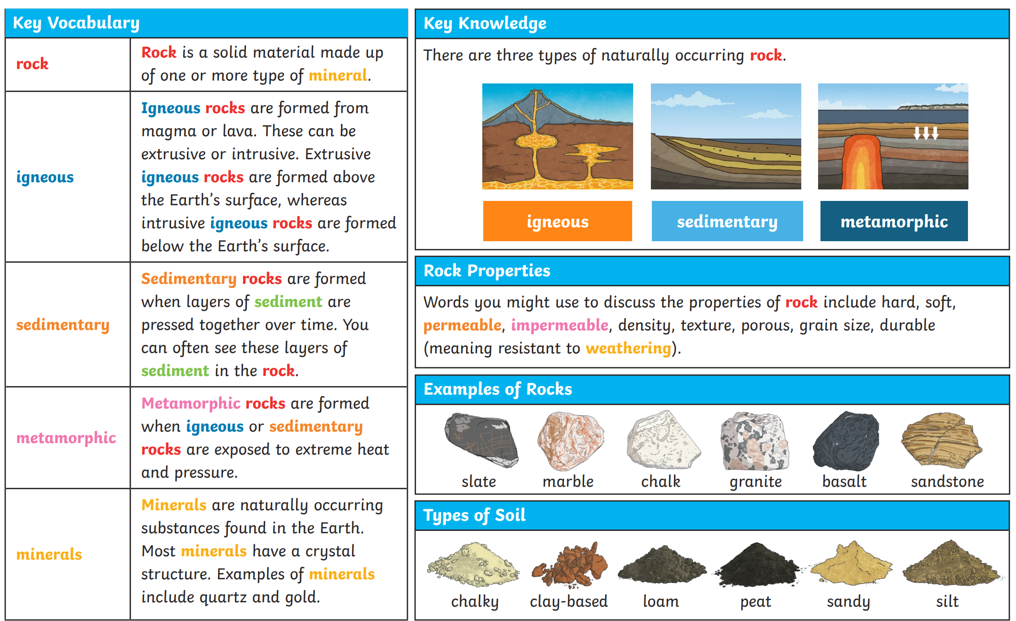

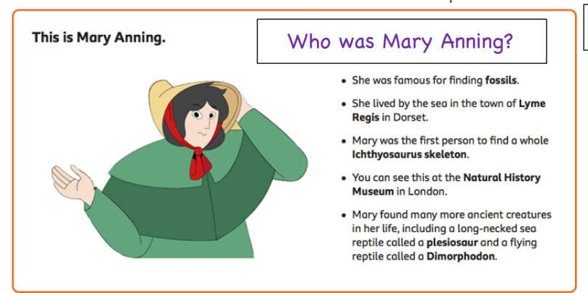
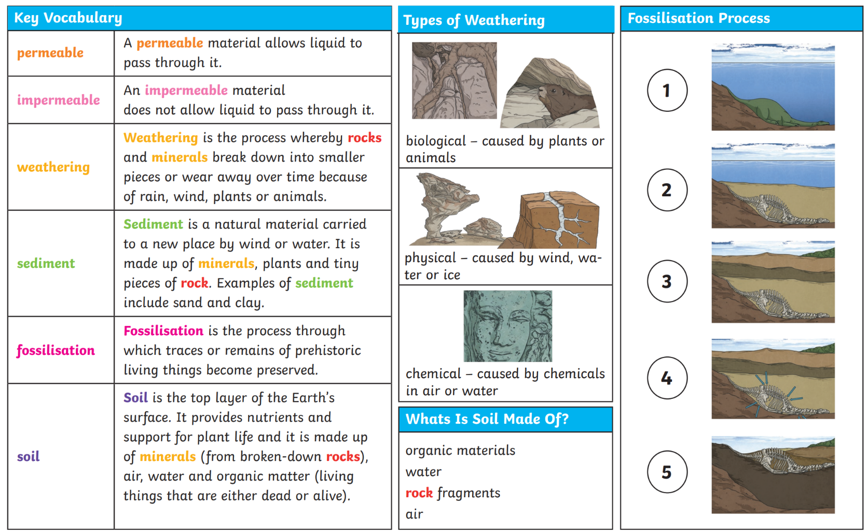
Petrologist, man-made rocks, brick, tile, concrete, erosion, identification key, survey, petrologist, data, database, micro-organisms, organic matter, particles, fair test, compare, sort, predict

Key Vocabulary

Mary Anning

