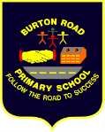
Engage and Inform!
Task: Write a non-chronological report

‘Write’ it right!
Curriculum – ‘Get Set’

Hidden figures by Margot Lee Shetterly

Andy Hawksworth - Sports Coach/PSP Co-ordinator

Text and author
This guide will help you to prepare and plan for your next writing task. You may wish to research the topic or simply talk about your ideas with an adult. You can write notes to help you be ready to write!

The School Library
Audience

To inform
Purpose

Writing Features Focus

Vocabulary:
How words are related by meaning as synonyms
Sentence:
Use of the passive to affect the presentation of information in a sentence
Text:
Linking ideas across paragraphs using a wider range of cohesive devices (repetition of a word or phrase, use of adverbials and ellipsis)
Layout devices
Punctuation:
Capital letters for sentence starters and proper nouns
Use of the semi-colon, colon and dash to mark the boundary between independent clauses
Use of bullet points to list information
Handwriting and Spelling:
Consistent letter sizing (capital letters bigger than lower case)
Join letters appropriately
Use spellings from the Y5/6 list and check unknown words using a dictionary

W A G O L L – what a good one looks like!

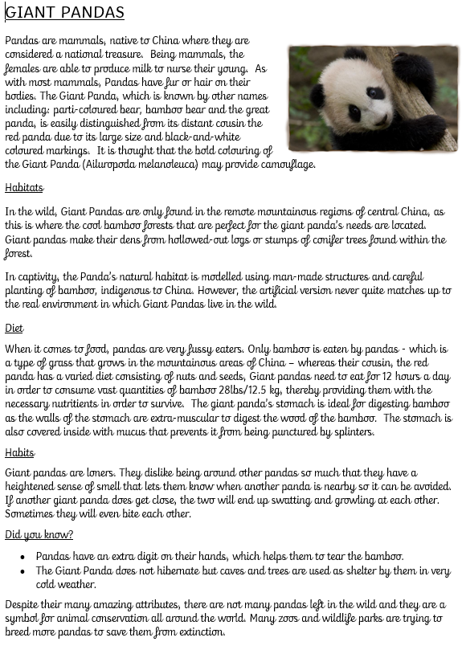

Communication

BRPS PE Twitter
PSP Twitter
Website
School Twitter/FB
Spectators at events
Gateway App
Dojos
Emails

Differentiation

Monitoring Feedback

Parent Voice
Pupil Voice
Staff Voice
Whole School Survey
Kobocca Survey
PSP Meetings
PE Meetings

Talk through your ideas or write notes to get you ready to write!

