Science – Seasonal Changes
- To know what the weather is like in Autumn.
- To know when the sun rises and sets in the Autumn.
- To know what the weather is like in Winter.
- To know when the sun rises and sets in the Winter.
- To know how the weather changes from Autumn to Winter.
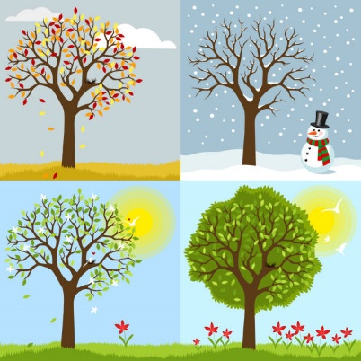
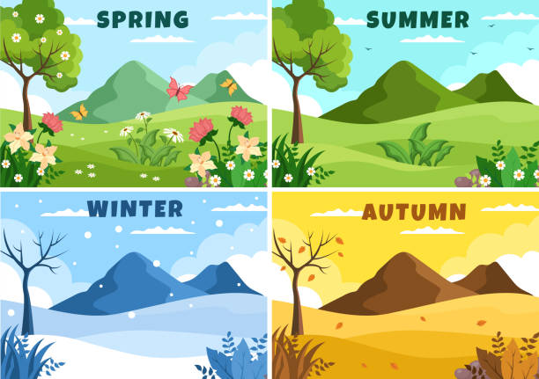

Music – Nativity (A Stable Hoedown)
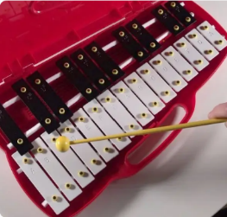


- Some songs can be found on YouTube if children wish to practise.

Geography – Our School
- To know the geography of our school so I can understand the geographical grounds.
- To know the difference between human & physical features so I can identify these around school.
- To use aerial photographs to recognise local landmarks so I can understand whether they are human or physical.
- To understand basic symbols so I am able to read identify these on a map.
- To know simple compass directions so I know the location of North, South, East and West.

- To use directional language so I understand how to describe locations and routes of a map.



DT – Eat more fruit and vegetables
- To know the different types of fruit and vegetables available.
- To know which fruit or vegetable is my favourite.
- To understand what I like about my favourite fruit or vegetables.
- To know the most popular fruit and vegetables in the class.
- To know how to identify different fruits and vegetables.
- To know how to describe different fruits and vegetables.
- To know how to explore and taste fruits and vegetables.
- To understand how to work safely with food.
- To know that fruit and vegetables need preparing before eating.
- To understand how to prepare different fruits and vegetables before eating them.
- To understand how tools work.
- To know how to use them safely.
- To know why eating fruit and vegetables is important.
- To know how to design a healthy meal using fruits and vegetables.
- To know how to design their own healthy salad or fruit salad.
- To know how to follow a design to make a product.
- To know how to work safely and hygienically.




Maths

- Addition & Subtraction within 10
- Place Value within 20
- Shape
- Position and Direction

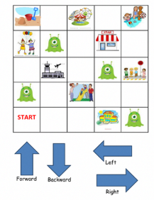
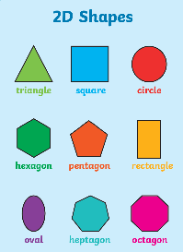
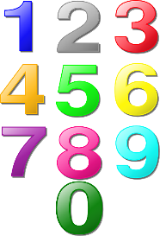



PSHE
Valuing Difference

How can we help at home?
- Read daily with your child
- Practise the letter formation, using Read, Write, Inc. rhymes sheet
- Orally counting forwards and backwards to 20
- Number bonds to 10
- Number formation
- Ask your child about 1 thing they have learnt at school each day
- Practise spellings each week
- Nativity songs and lines practise (if required for your child).

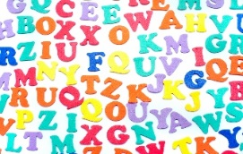


Spellings – Autumn 2
We will be doing a weekly test of 5 spellings from the KS1 common exception word list. These are words which do not follow regular spelling patterns. The test day will vary and the children will also be exposed to these words in class. Please help them to learn these. We recommend the ‘look, say, cover, write, check’ method. Some words are recapped from last half term to address misconceptions in spellings.
Test w/c 11th November | - full  - friend  - today  - was  - me
Test w/c 18th November | - she  - your  - I  - as  - we
Test w/c 25th November | - do  - the  - you  - said  - she
Test w/c 2nd December | - once  - school  - house  - our  - ask
Test w/c 9th December | - our  - to  - pull  - your  - so

