Science – Everyday Materials
- To know who Charles Mackintosh was.
- To know how to test different materials for the best waterproof ‘sandwich’.
- To know the difference between the name of an object and the material from which it is made.
- To know the names of common everyday materials.
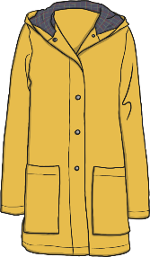
- To know what the properties of a material are.
- To describe the properties of materials.
- To know how to group materials based on their properties.
- To know what suitability means.
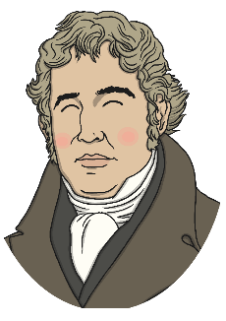
- To know how to test the suitability of a material.
- To know why Mackintosh’s coat was not ‘perfect’.
- To know what was wrong with the design of Mackintosh’s coat.

- To know that some objects can be changed.

Music – Keeping the Pulse
- Clap the rhythm of their name in time to the pulse.
- Sway or tap in time to the pulse.
- Sing a rhythm in time with the pulse.
- Copy rhythms based on word patterns using an instrument.
- Keep the pulse while playing a rhythm on an instrument.
- Follow instructions during a performance.


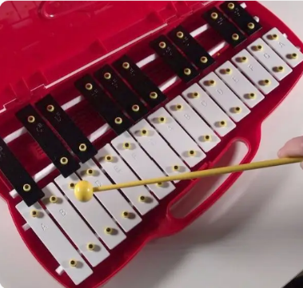

Art - Self Portraits
- To know what a self-portrait is
- To communicate something about themselves
- To paint a picture of something they can see
- To know facts about Pablo Picasso
- To name the primary and secondary colours
- To be able to mix paint to create all the secondary colours
- To mix and match colours, and predict outcomes
- To choose thick and thin brushes as appropriate
- To mix and match colours, and predict outcomes
- To make tints by adding white
- To make tones by adding black
- To create a self-portrait in the style of Pablo Picasso
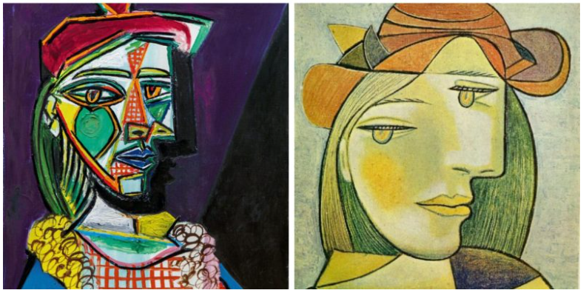


History – Our Changing School
- To know my school building has changed over time.
- To know what primary sources are.
- To know how my school has changed over time using primary sources.
- To know what a timeline is and use it to order in chronological order.
- To know how school life in 1978 differs to the present day.
- To know the school and school life has changed (the building, lessons taught, what the children wore and how they were allowed to act).



Maths

- Place value within 10
- Addition & Subtraction within 10
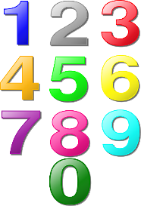

PSHE
- Me and My Relationships

How can we help at home?
- Read daily with your child
- Practice the letter formation, using Read, Write, Inc. rhymes sheet
- Orally counting forwards and backwards to 20
- Number formation
- Ask your child about 1 thing they have learnt at school each day
- Practise spellings each week

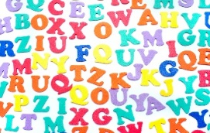

Spellings – Autumn 1
We will be doing a weekly test of 5 spellings from the KS1 common exception word list. These are words which do not follow regular spelling patterns. The test day will vary and the children will also be exposed to these words in class. Please help them to learn these. We recommend the ‘look, say, cover, write, check’ method.
Test w/c 9th September | - is  - I  - a  - do  - we
Test w/c 16th September | - the  - you  - said  - she  - once
Test w/c 23rd September | - no  - was  - of  - be  - one
Test w/c 30th September | - are  - his  - he  - me  - go
Test w/c 7th October | - come  - there  - my  - they  - love
Test w/c 14th October | - our  - to  - pull  - ask  - put
Test w/c 21st October | - school  - your  - so  - says  - by
Test w/c 28th October | - were  - some  - has  - here  - push

