Burton Road Primary School Vision for PSHE.
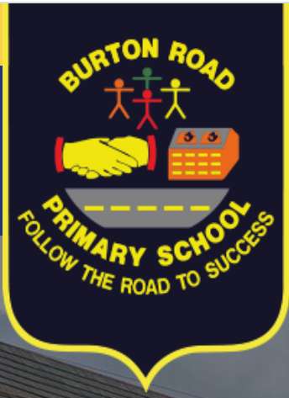

We want all our children to transition to KS3 with the knowledge, self- esteem, confidence and awareness to make informed choices and decisions making them responsible members of society.
We have a whole school approach from Nursery to the end of KS2 in ensuring positive dispositions and attitudes are developed and maintained with our ‘Golden Values’ underpinning our school culture. We aim to help our children to understand how they are developing personally and socially, and tackle many of the moral, social and cultural issues that are part of growing up.
We strive to provide our children with learning opportunities across and beyond the curriculum, in specific lessons, circle time, special school projects and other activities that enrich pupils’ experiences.
Our children are encouraged to develop their sense of self-worth by playing a positive role in contributing to school life and the wider community.
‘Wellbeing Warriors’ who sit on our school council are our ambassadors, helping to ensure pupil voice during break times and promoting positive mental wellbeing.

